MAKTAWAE LABRADOR RETRIEVERS
CKC Perm. Reg’d since 1984
Lola Nichol
maktawaelabradors.weebly.com maktawaegundogs@gmail.com

Pedigree for:
Maktawae Wannabe An Outlaw “Shooter”
DOB: November 25, 2022

sire  MBIS/MBISS/BOSS/MRBIS/MBPIS/ GCHEX. GCh Gold. DANRICH ON D'RUN TO MAKTAWAE WC. "Colt"  Hips/Elbows OFA Excellent Hips/Elbows Clear- Cardiac Doppler Echo Clear - HNPK Carrier- Copper Toxicosis Carries Protective Gene-Eyes Clear- EIC- Clear-CNM- PRA-DD-RD/OSD-Narcolepsy- DM-CRD Clear by Parentage  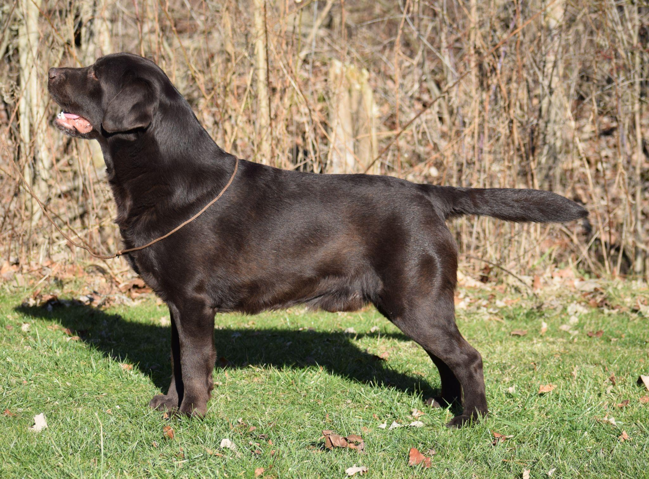 | Am Ch./BISS Can GCh. SKYFIRE’S  JEDI MASTER “Yoda”  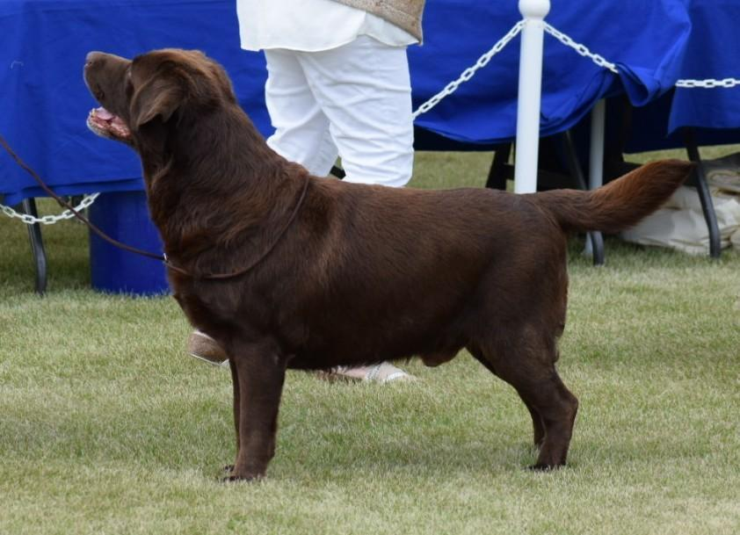 | MBISS Am.CH. EPOCH’S MOCCASIN JOE  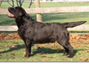  SKYFIRE’S FUN ON THE RUN  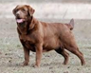  MBISS Am.GCH. ZINFNDEL’S SPANISH OAK  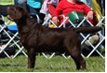  CEDARWOOD HEIRLOOM 4 COFFEE NUDGE  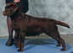
GCh. HEIRLOOM’S TRANSPORT TO DANRICH “Lucy”
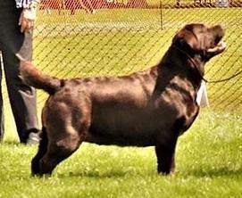

dam  GCh Catrtaz Cast A Spell On Maktawae “Cassi” (Australian Imp)  Hips/Elbows OFA Excellent/Clear- Cardiac Echo clear -Eyes- Clear EIC-CNM- PRA Clear by Parentage - HNPK-DM-DD Dilute-clea  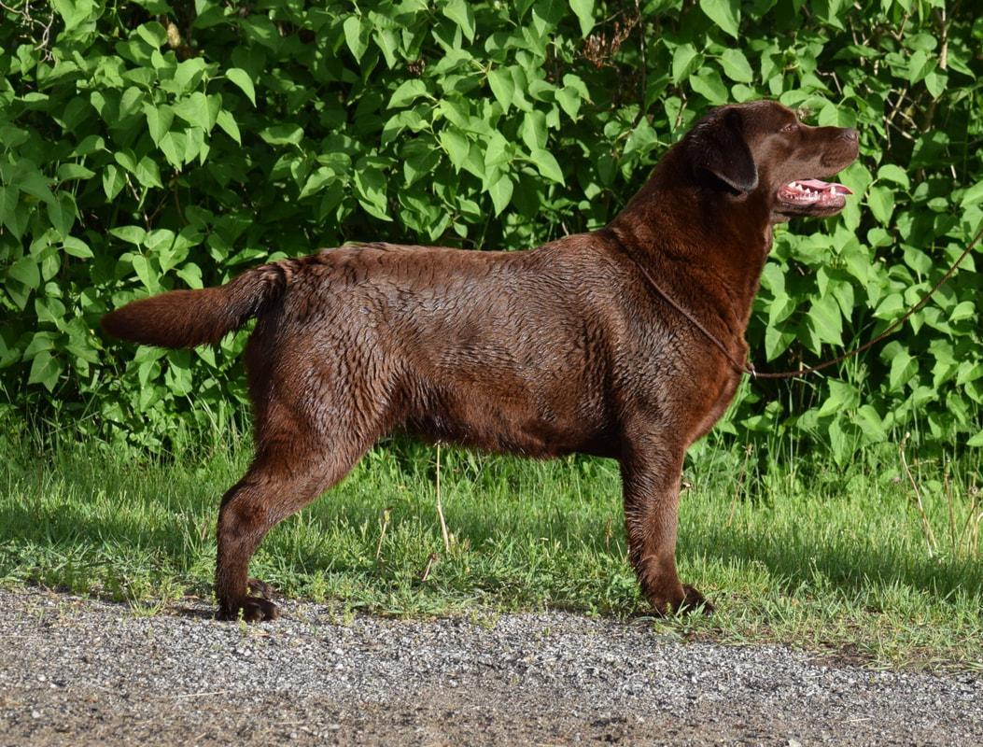 | Australian CH. Catraz Master Magician “Tommy”Hips 1:1 Elbows 0:0 PRA,EIC & CNM Clear  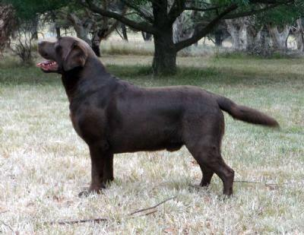 | Brigburn Finney (Eng. import)  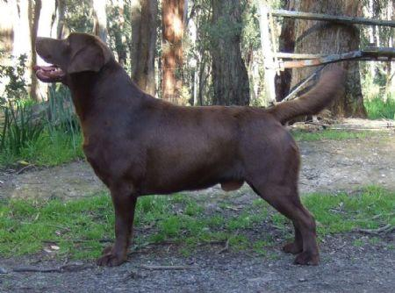  Aust. Ch. Catraz Charmed One  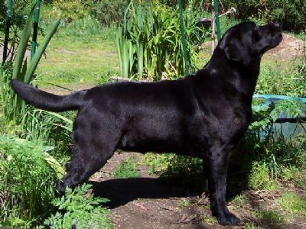
 | Australian CH. Catraz Bold N Brassy”Sassy”  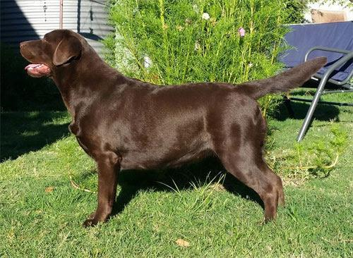 | BISS Aust. Ch, Blackrange Sorcerer’s Apprentice “Charlie”  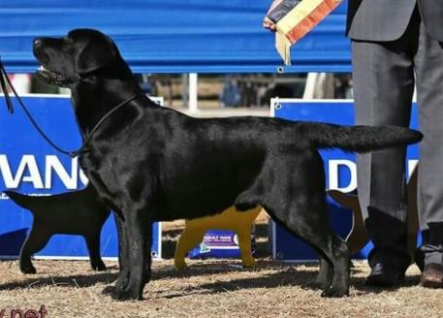  Aust. Ch. Catraz Miss La De Da  